**Presenting the Results of a Potthoff Analysis**

Subjects were undergraduate students at East Carolina University who participated in this research to satisfy, in part, the research participation requirement for an introductory course in psychology. Students completed Wuensch’s measure of attitudes about animal rights (AR), Wuensch’s measure of misanthropy (MIS), and Forsyth’s Ethics Position Questionnaire (EPQ). Based on their score on the Idealism subscale of the EPQ, subjects were classified as being idealistic or not idealistic.

A Potthoff analysis (simultaneous test of slope of intercept) was conducted to determine whether the slopes and intercepts for predicting AR from misanthropy differed between the groups. The analysis revealed that the regression lines for the two groups were not coincident, *F*(2, 150) = 3.623, *p* = .029. Follow-up analyses revealed that the two groups did differ significantly in slopes, *t*(150) = 2.25, *p* = .026, as well as in intercepts, *t*(150) = 2.58, *p* = .011. As shown in Figure 1, the slope was significantly higher in the group of nonidealists, and the intercept was significantly higher in the group of idealists.

Within the nonidealistic group, AR was significantly related to misanthropy, , *t*(89) = 3.69, *p* <.001, *r* = .364, 95%CI [.171, .530]. Within the idealistic group, AR was not significantly related to misanthropy, , *t*(61) = 0.16, *p* = .87, *r* = .02, 95% CI [-.228, .338].

Figure 1. Predicting AR from Misanthropy in Idealists and Nonidealists.

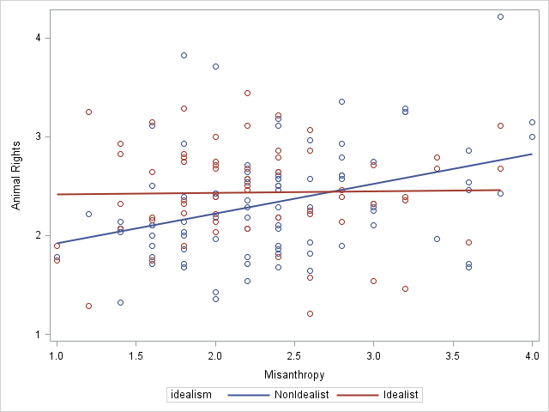

Notice that I probed the interaction by finding the within-groups regressions. An alternative procedure is to use Hayes’ Process to test the simple effects of misanthropy on support of animal rights.

%***process*** (**data**=Potthoff,y=ar,x=Misanth,w=Idealism,model=**1**,jn=**1**,plot=**1**)

|  |
| --- |
| Conditional effects of the focal predictor at values of the moderator(s): |

| **IDEALISM** | **Effect** | **se** | **t** | **p** | **LLCI** | **ULCI** |
| --- | --- | --- | --- | --- | --- | --- |
| 0.0000 | 0.3001 | 0.0806 | 3.7230 | 0.0003 | 0.1408 | 0.4593 |
| 1.0000 | 0.0153 | 0.0974 | 0.1575 | 0.8751 | -0.1771 | 0.2078 |

|  |
| --- |
| Data for visualizing the conditional effect of the focal predictor: |

|  | | |
| --- | --- | --- |
| **MISANTH** | **IDEALISM** | **AR** |
| 1.6000 | 0.0000 | 2.1059 |
| 2.2000 | 0.0000 | 2.2859 |
| 3.0000 | 0.0000 | 2.5260 |
| 1.6000 | 1.0000 | 2.4290 |
| 2.2000 | 1.0000 | 2.4382 |
| 3.0000 | 1.0000 | 2.4505 |

**data** plot; input Misanthropy Idealism Animal_Rights;

cards;

1.6000 0.0000 2.1059

2.2000 0.0000 2.2859

3.0000 0.0000 2.5260

1.6000 1.0000 2.4290

2.2000 1.0000 2.4382

3.0000 1.0000 2.4505

**proc** **sgplot**; reg x = misanthropy y = Animal_Rights / group = Idealism nomarkers;

yaxis label='Support of Animal Rights';

xaxis label='Misanthropy'; **run**;

If you take the approach Hayes prefers, replace the description of the within-group regressions with something like this: As shown in Figure 1, the slope (.30) for predicting attitude from misanthropy was significant in the nonidealistic group, 95% CI [.14, .46], but not in the idealistic group (.02), 95% CI [-.18, .21].

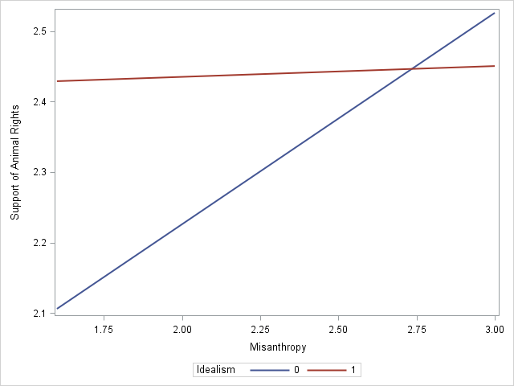

[Karl L. Wuensch](http://core.ecu.edu/psyc/WuenschK/KLW.htm), October, 2019.